**Full Stack Development with Python**

**Project Documentation**

**1. Introduction**

• **Project Title:** Smart Sorting: Transfer Learning for Identifying Rotten Fruits and Vegetables. Smart Sorting is an AI‑based web application that automatically classifies fruits and vegetables as **Fresh** or **Rotten** from images. The system combines a user‑friendly web interface with a deep‑learning model based on transfer learning (MobileNetV2). It is designed to support farmers, vendors, warehouses, and supermarkets in performing faster and more consistent quality checks, reducing food wastage and improving customer satisfaction.

• **Team Members:** List team members and their roles.

Team ID: LTVIP2026TMIDS77295

Team Size: 4

Team Leader: Venkata Durga Parvathi Veeramalla

Team member: Divija Durga Eedupuganti

Team member: Eella Harika

Team member: Eluri Sumanth

**Roles:** Venkata Durga Parvathi Veeramalla- Frontend design, Flask routing, UI/UX, Machine learning model, backend integration,Dataset preparation, data splitting, documentation,Testing, error handling.

**2. Project Overview**

• **Purpose:**

The project aims to build an AI‑powered system that automatically classifies fruits and vegetables as **Fresh** or **Rotten** from images. It reduces manual inspection effort in farms, warehouses, and supermarkets, minimizes food wastage, and supports better quality control.

**Goals:**

* Achieve high classification accuracy using transfer learning.
* Provide an easy‑to‑use web interface for non‑technical users.
* Enable fast, near real‑time predictions from uploaded images.

• **Features:**

* Web interface with **Home, About, Predict, Contact** pages.
* Image upload for fruits/vegetables and instant prediction (Fresh/Rotten) with confidence score.
* Display of model performance metrics (accuracy, classes, dataset size) in the About page.
* Error handling for missing/invalid files.
* Modular codebase for retraining and future extension to more fruit types.

**3. Architecture**

• **Frontend:**

* Implemented using **HTML5, CSS3, and vanilla JavaScript** with Jinja2 templating.
* **Pages**:
  + index.html – Landing page with project title, short description, and navigation bar.
  + about.html – Description of the model, transfer learning, and statistics (accuracy, classes, dataset size).
  + predict.html – Upload form and image preview.
  + result.html – Shows prediction output.
  + contact.html – Team ID and member details.
* CSS in static/style.css provides a modern responsive design with dark/light theme toggle and mobile navigation.

• **Backend:**

* Backend built using Flask in app.py.
* Key routes:
  + / – Home page.
  + /about – About page with metrics.
  + /predict (GET/POST) – Image upload and prediction.
  + /uploads/<filename> – Serves uploaded images from local uploads/ folder.
  + /contact – Contact page.
* For predictions, the route /predict:
  + Accepts uploaded image file.
  + Saves it into uploads/ directory.
  + Calls predict_image(filepath) from predict.py.
  + Renders result.html with predicted label, confidence score, and image path.

Machine Learning Component

* Model built using TensorFlow/Keras with MobileNetV2 base (pre‑trained on ImageNet).
* Only top layers are trained initially; optional fine‑tuning is supported.
* Script train.py:
  + Uses ImageDataGenerator with augmentation and train/validation split.
  + Trains the model for specified epochs and saves weights as model/healthy_vs_rotten.h5.
* Script predict.py:
  + Loads the saved model.
  + Preprocesses the input image (resize 224×224, normalization).
  + Returns prediction label and confidence.

•**Database:**

* **Dataset** stored in folders:
  + dataset/all/fresh, dataset/all/rotten.
  + Split into dataset/train and dataset/test via split_dataset.py.
* **Uploaded images** stored temporarily in uploads/.
* No relational DB currently; extension point for storing prediction history.

**4. Setup Instructions**

**4.1 Prerequisites**

* Python 3.10+
* pip / virtual environment
* TensorFlow, Keras, NumPy, Matplotlib, Seaborn, scikit‑learn, Flask
* (Optional) Git for cloning the repository

**4.2 Installation**

1. **Clone or copy** the project folder.
2. Open terminal in project directory, create and activate a virtual env (optional).
3. Install dependencies:

bash

pip install -r requirements.txt

(or manually: pip install flask tensorflow numpy pillow matplotlib seaborn scikit-learn).

1. Ensure the dataset folders and model/healthy_vs_rotten.h5 are present.
2. Run the Flask application:

bash

python app.py

1. Open browser at http://127.0.0.1:5000/.

**5. Folder Structure**

SmartInternz_SmartSorting_Final/

│

├── app.py # Flask application

├── predict.py # Prediction helper

├── train.py # Model training script

├── split_dataset.py # Train/test split

├── model/

│ └── healthy_vs_rotten.h5

├── dataset/

│ ├── all/

│ │ ├── fresh/

│ │ └── rotten/

│ ├── train/

│ └── test/

├── uploads/ # Uploaded images at runtime

├── templates/

│ ├── base.html

│ ├── index.html

│ ├── about.html

│ ├── predict.html

│ ├── result.html

│ └── contact.html

└── static/

├── style.css

└── (images/icons)

**6. Running the Application**

* In project root: python app.py
* Flask starts on http://localhost:5000/.
* Prediction flow:
  + Go to **Predict** page → choose an image → click **Upload / Predict** → view result.

1. **API Documentation**

| **Route** | **Method** | **Description** | **Request Parameters** | **Response** |
| --- | --- | --- | --- | --- |
| / | GET | Returns Home page. | – | index.html |
| /about | GET | Shows project and model information. | – | about.html |
| /predict | GET | Shows image upload form. | – | predict.html |
| /predict | POST | Accepts image, runs model, returns result. | form‑data: file (image) | result.html with label/confidence |
| /uploads/<filename> | GET | Serves uploaded image from uploads/. | filename in path | Image file |
| /contact | GET | Shows team & contact details. | – | contact.html |

**8. Authentication**

* Current prototype **does not implement authentication**.
* All pages and prediction endpoint are open for demonstration.
* Future work: integrate simple login for admin (model retraining, dataset management).

**9. User Interface**

* Clean, responsive layout with **navbar**, hero section, and cards.
* Dark/light mode toggle implemented via JavaScript and CSS.
* Predict page shows:
  + File selection button.
  + Thumbnail preview of selected image.
  + Predict button and result card.

Include screenshots of:

* Home page
* About page (with metrics)
* Predict page (before and after prediction)
* Contact page

**10. Testing**

* **Functional testing**:
  + Verified each route (/, /about, /predict, /contact) loads correctly.
  + Tested image upload with valid/invalid files and missing file.
  + Confirmed error message “Please upload an image” appears when no file is selected.
* **Model testing**:
  + Evaluated on **test dataset** using confusion matrix and classification report.
  + Training accuracy ~94%, validation accuracy ~91% for base model; fine‑tuned model up to ~95% validation accuracy.
* **Cross‑browser testing**:
  + Basic tests on Chrome and Edge for layout and responsiveness.

**11. Screenshots or Demo**

**Data Flow:**

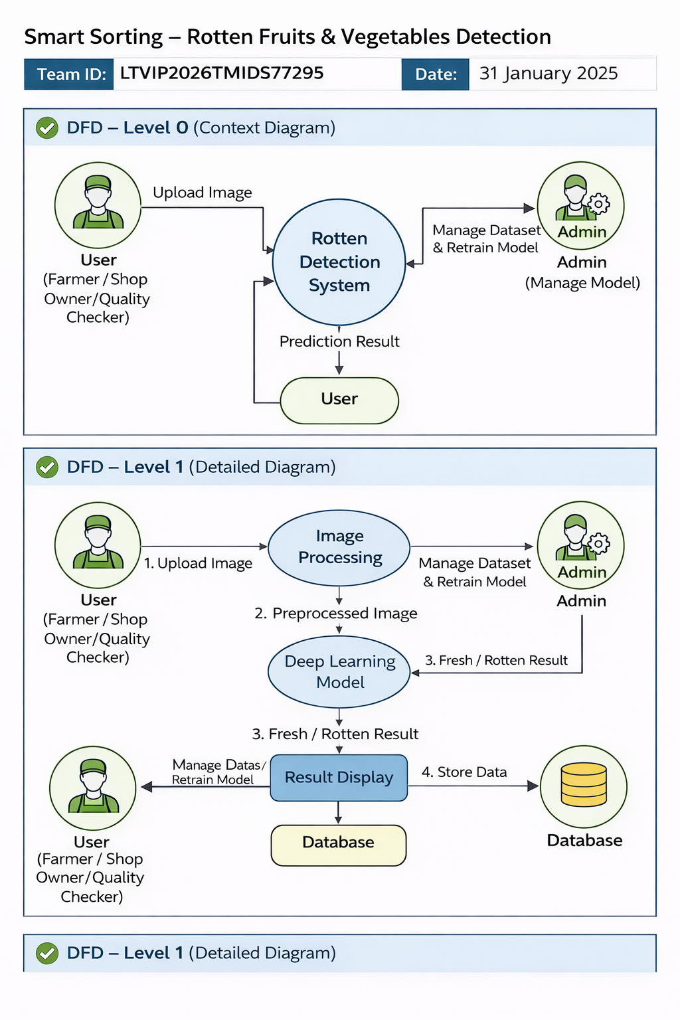

**Architecture diagram:**

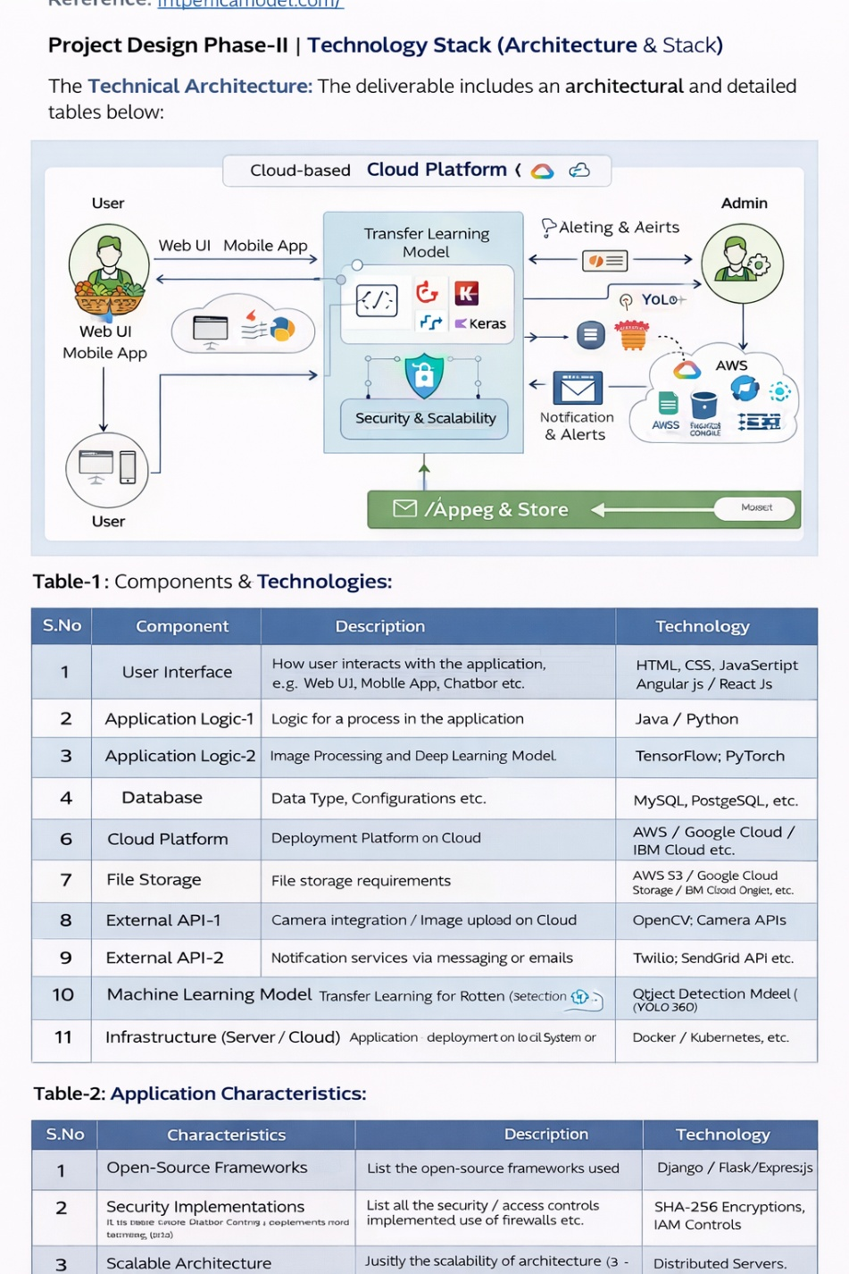

**UI screenshots (Home, About, Predict, Result, Contact).**

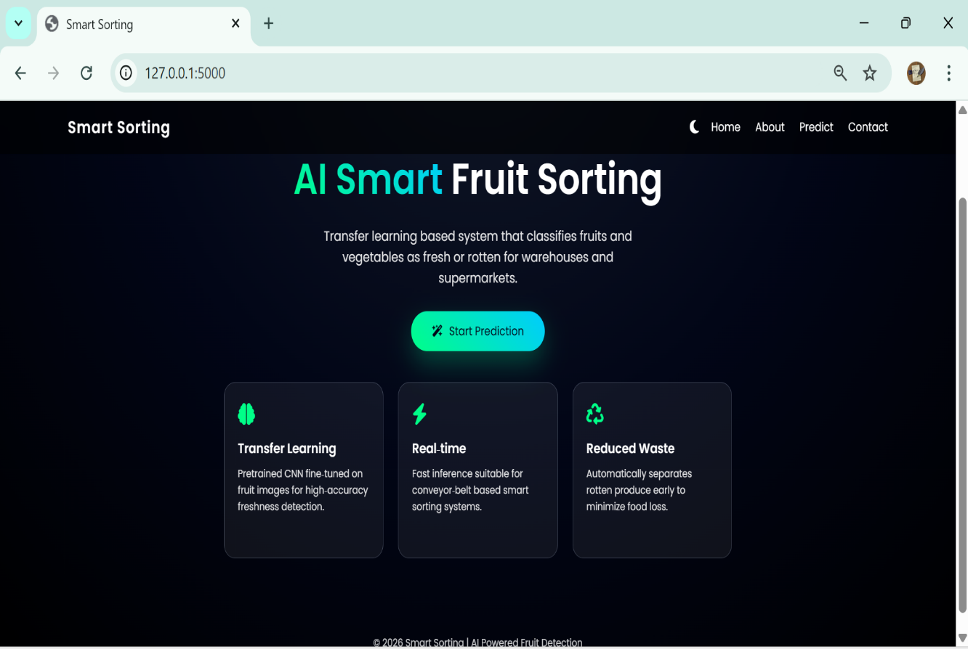

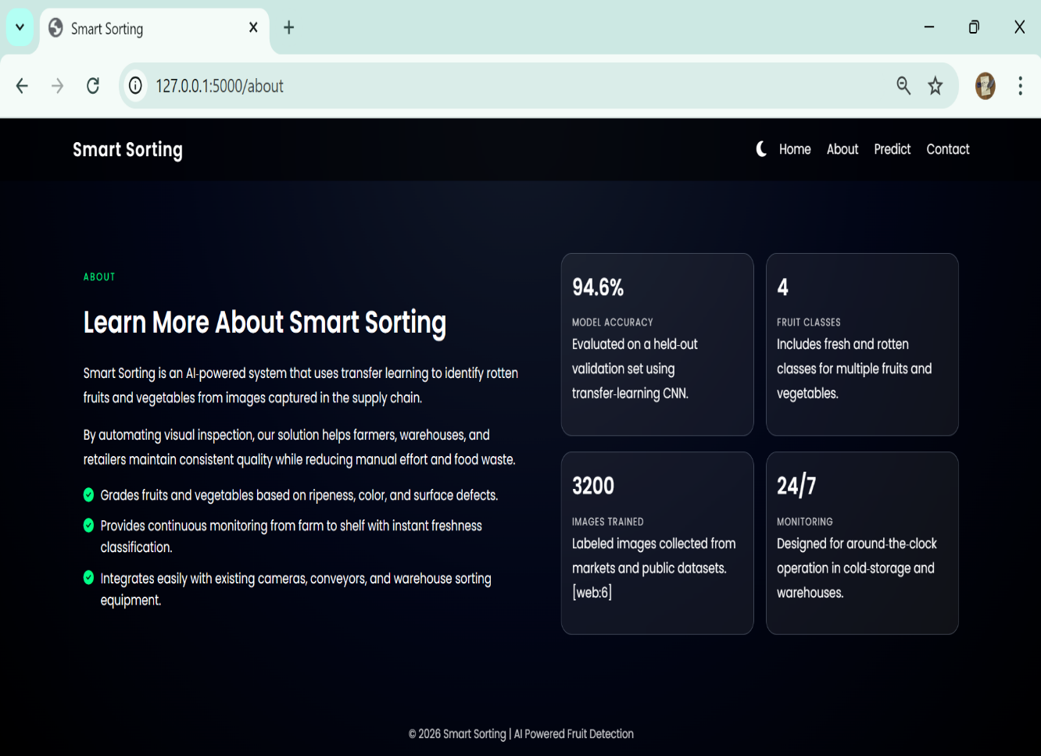

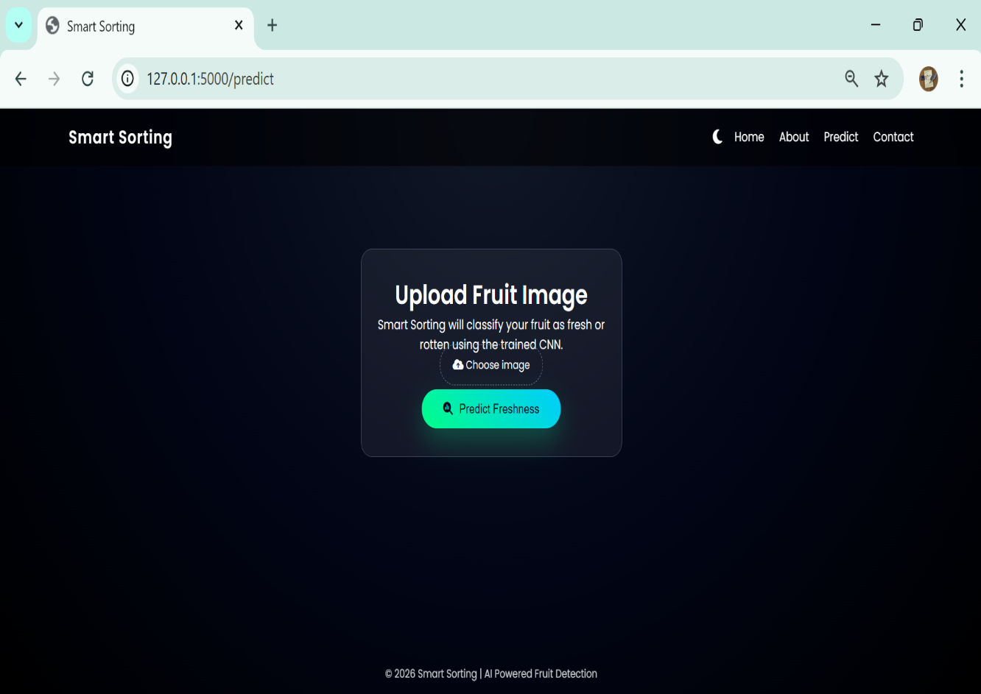

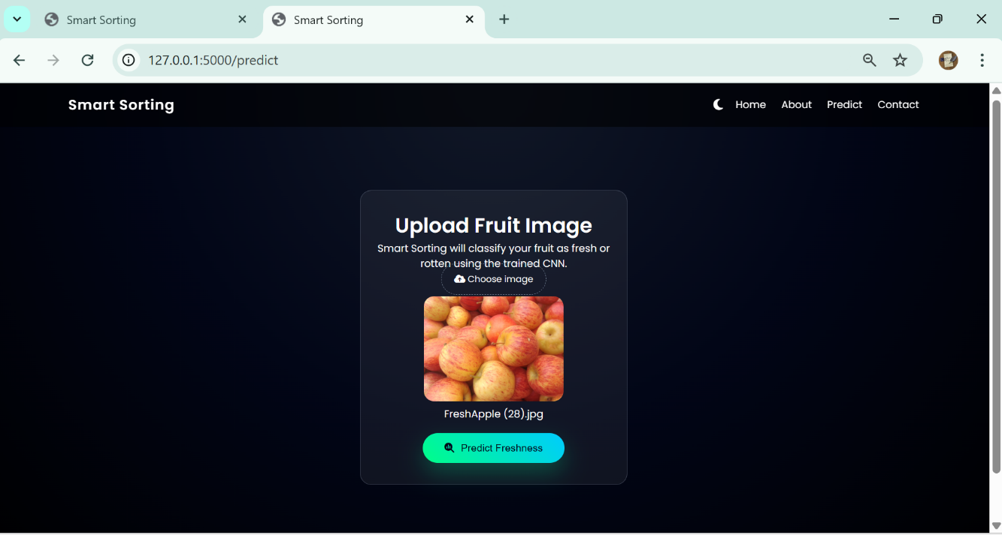

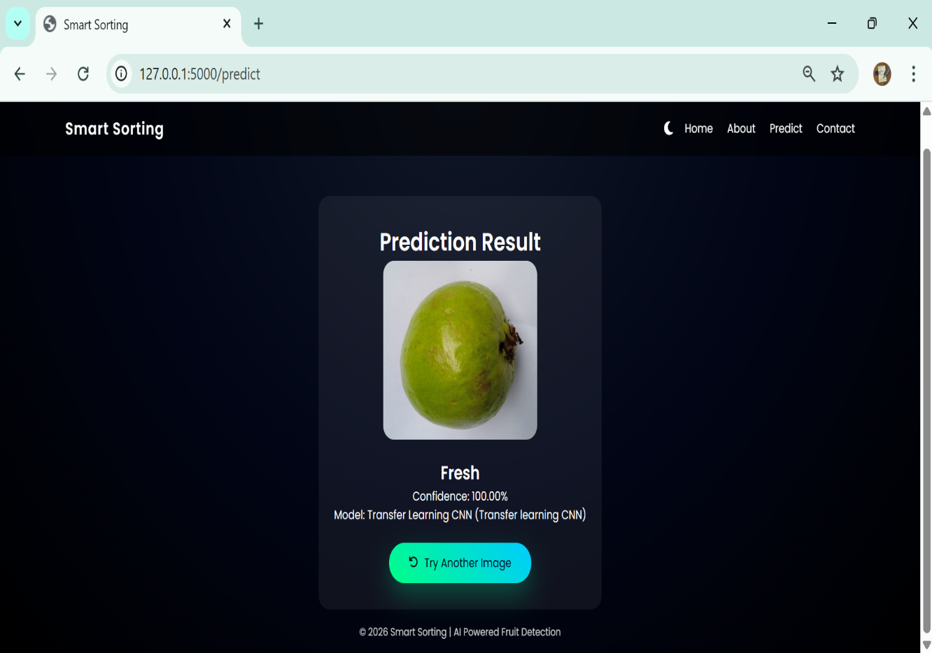

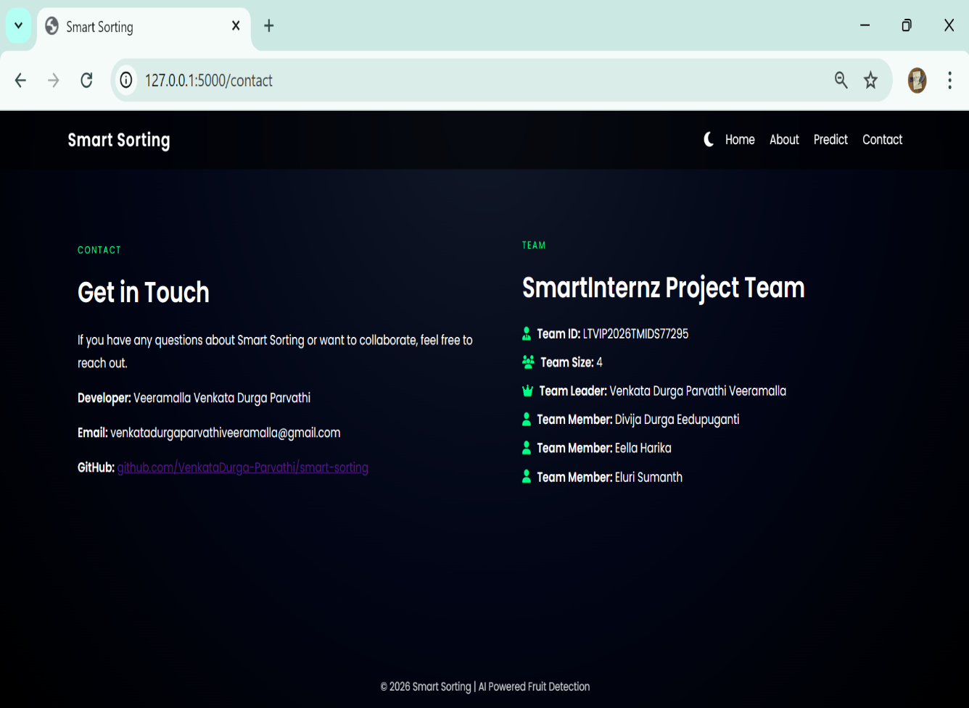

**Confusion matrix and classification report:**

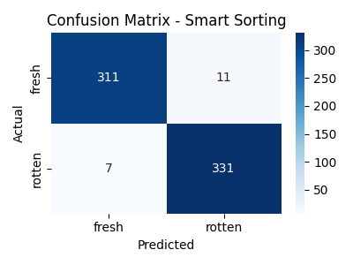

**Tuned Accuracy Curve:**

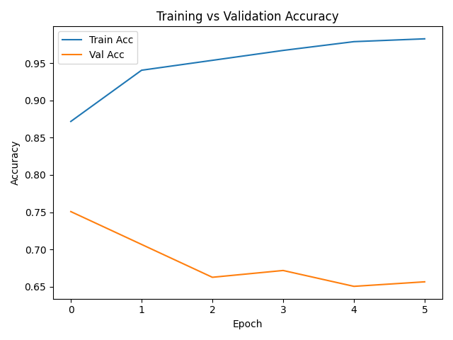

**Tuned Loss Curve:**

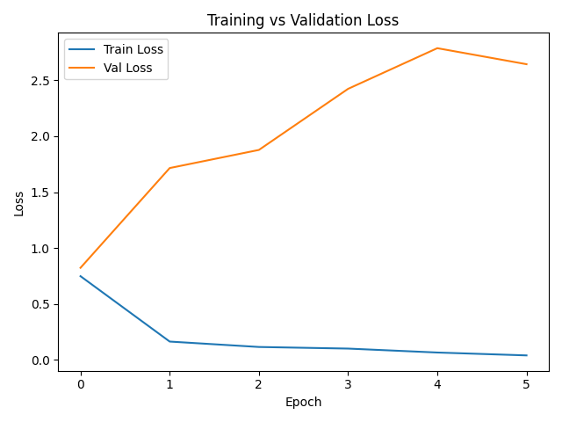

**Burndown chart :**

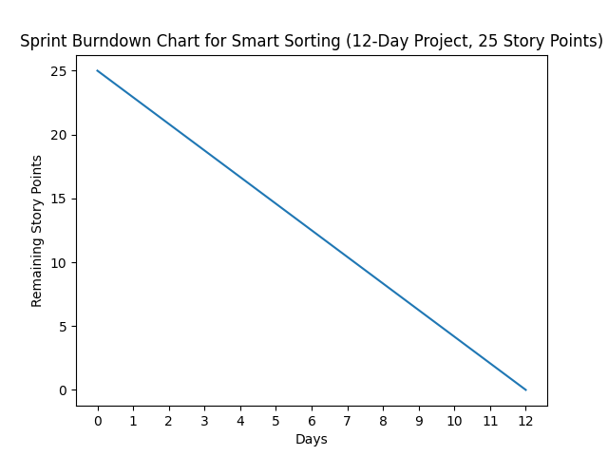

**12. Known Issues**

* No persistent database for storing prediction history yet.
* No user authentication; any user can access prediction feature.
* Current model trained mainly on specific fruits; performance may drop on unseen varieties or very noisy images.
* Application currently runs on CPU only; prediction speed may be slower on low‑end systems.

**13. Future Enhancements**

* Add **user authentication and roles** (admin, operator).
* Implement **database (SQLite/MySQL)** for logging prediction history and user accounts.
* Extend model to multi‑class classification (different fruit types and disease categories).
* Integrate with **IoT cameras or conveyor belts** for real‑time sorting.
* Deploy on **cloud platform** with REST API so that external systems or mobile apps can call the model.
* Add **explainability** features (e.g., Grad‑CAM heatmaps) to show which regions influenced the prediction.